Computer Graphics lab project (25%)

1. Write an openGL code to display horizontal stripes of lines on the screen as follows.

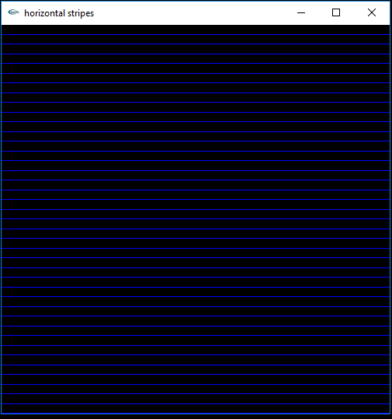

1. Write an openGL code to display an image similar to fig1 given below.

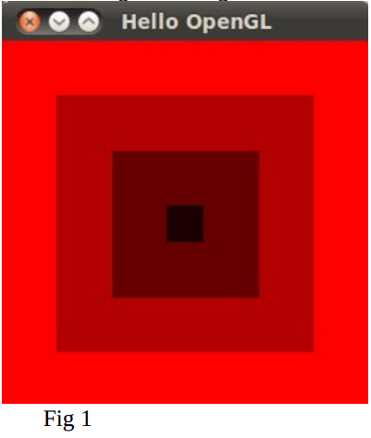

1. Modify your code for question number 2 to display the following image.

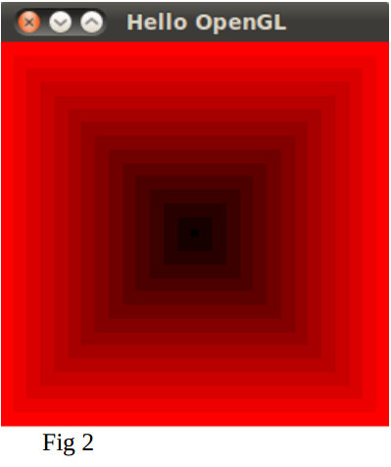

1. Write an openGL code to draw a line with vertices (0,0) and (0.6,0.6) and to handle keyboard inputs to rotate the line 45 degrees clockwise (to the right) when ‘r’ key is pressed and rotate the line 45 degrees anticlockwise (to the left) when ‘l’ key is pressed.
2. Write an OpenGL program that draws a Cube.
3. Write an OpenGL program that draws a wired Wheel.
4. Write an OpenGL program that draws a wired Cone.

* The code has a demonstration.